1. Project structure and Page Object Model design - folders, layers, naming (show the structure as a tree). What is a page object here, how do tabs and repeated field types fit, and how do you avoid one 900-line class?
Answer :
Each tab can be a page object in our project structure and all the fields inside each tab & associated page specific actions comes in the pages.java files
Common code logic to handle repeated field types like – text box, dropdown and checkbox comes in the BasePage.java – i.e, the common logics that can be used across all the pages
By structuring in this way, we can avoid 900 line class and have small piece of code that is reusable and maintainable by avoiding duplicate coding work.
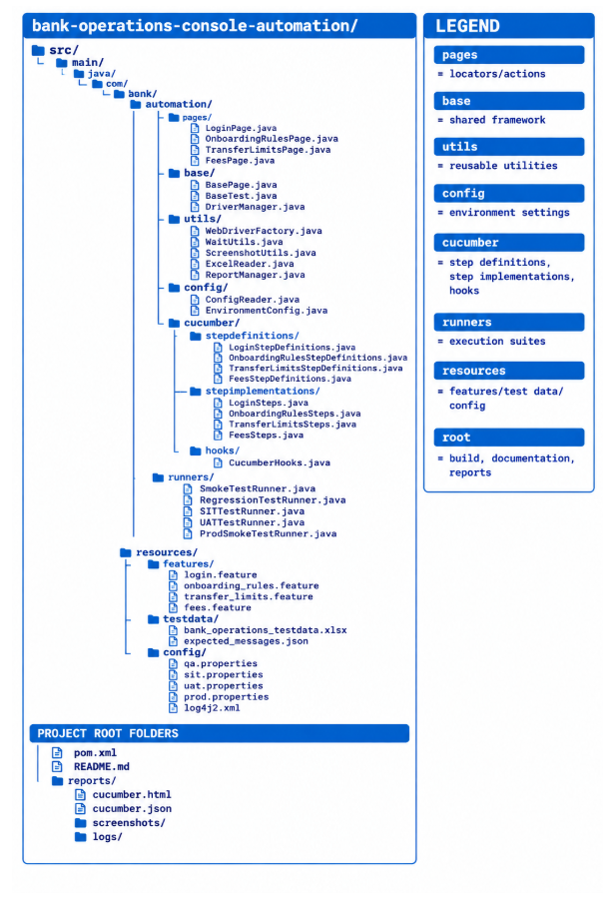
2. Locator strategy - how you identify a field reliably given the dynamic identifier, and how you handle the three different control types behind one interface. Be specific.
Answer :
- I would handle Dynamic fields using a relative xpath or axes , by identifying a stable element and navigate to the required dynamic element using relative xpath.
Requirement states “Every configurable item follows the same stable parent-wrapper structure. The wrapper can be located by its visible label text or by a unique descriptive attribute”
- To handle the different control types (text fields, checkboxes and drop-down lists.), I will create a common interface, then create one implementation for each control type ( implement the interface in the class that extends them)

For Example, Select method in checkbox and dropdown will have their own implementation logic in their respective classes that implements the interface

3. Handling dynamic DOM — elements changing on tab switch and scroll, stale references, waiting strategy. What do you not do?
Answer :
- Use explicit waits to determine the element state before going further.
- Use stalenessOf() for elements detached from the DOM and refreshed() for conditions where the element may be redrawn during the wait
- Use exception handling to implement retry logic with a maximum retry count - in case if the element has become stale or no longer exists
Dont’s :
- Don’t store the elements which change on tab switch or scroll (becomes stale or refreshed)
- Don’t use implicit waits or Thread.sleep
- Don’t use absolute xpath for dynamic elements that get refreshed
- Avoid using page factory model as much as possible when the elements are dynamic like this

4.Test data strategy - no hard-coded values. Where data lives, how you handle values that must be unique per run, and how you leave the environment clean. Assume test environments are shared with other teams, data is restricted, and you cannot reset the database on demand - tell us how that shapes your design.
Answer :
- In our project structure test data is kept under resources/test data folder
- To keep environment clean, we can write the logic for clean up in the hooks file using the @After tag. This can happen the report is published during the tear down stage.
- For the dynamic data we can have logic to generate the test data randomly. But we need more info about what sort of fields require a unique value and this can be implemented further based on it.

5. Reusability and scalability - what a new engineer writes to add a 5th tab or a 20th field; execution time, parallelism, CI integration and reporting as the suite grows from 7 tabs to 20.
Answer :
For a new tab, we need to add a new pages class, step definition, step implementation and feature file only as required & Reuse the rest of the framework we already designed, including the reusable methods for commonly used actions on webelements
For a new fields, its even more simpler that we can just add the locator of the new element in whichever page or element it is introduced in. After this it can be used wherever it is required. Page method for the specific method can be added if required.

To handle execution time and parallelism, we can group the test cases using tags and can the run the test cases in parallel using multiple runner files

6. Tooling - the stack you would choose and why. Tell us the trade-off you accepted, not only the choice you made.
Answer :
I choose selenium, Java, cucumber and Maven as the stack for my testing.
For a banking project perspective I would like to Test exactly the Chrome, Edge, Firefox, or Safari version used by customers rather than Testing modern browser engines consistently using Playwright-managed versions.
Also I would prefer the use the Selenium infrastructure that the organization already has rather than building a framework from scratch.
Trade offs accepted include, more explicit framework design like handling scenarios with webdriver wait for elements to load, handle stale elements, etc.

